**(6428317 Mukesh P)**

## **WEEK 7 - MANDATORY HANDS ON**

## **EXERCISE 9**

## **Objectives**

* List the features of ES6
* Explain JavaScript let
* Identify the differences between var and let
* Explain JavaScript const
* Explain ES6 class fundamentals
* Explain ES6 class inheritance
* Define ES6 arrow functions
* Identify set(), map()

In this hands-on lab, you will learn how to:

* Use map() method of ES6
* Apply arrow functions of ES6
* Implement Destructuring features of ES6

App.js:

import React from 'react';

import ListofPlayers from './ListofPlayers';

import Scorebelow70 from './Scorebelow70';

import { OddPlayers } from './OddPlayers';

import { EvenPlayers } from './EvenPlayers';

import ListofIndianPlayers from './ListOfIndianPlayers';

const T20Players = ['First Player', 'Second Player', 'Third Player'];

    const RanjiTrophyPlayers = ['Fourth Player', 'Fifth Player', 'Sixth Player'];

    export const IndianPlayers = [...T20Players, ...RanjiTrophyPlayers];

function App() {

    var players = [

        { name: "Virat", score: 95 },

        { name: "Rohit", score: 65 },

        { name: "Gill", score: 72 },

        { name: "Pant", score: 45 },

        { name: "Iyer", score: 88 },

        { name: "Jadeja", score: 66 }

    ];

    const IndianTeam = ["Virat", "Rohit", "Gill", "Pant", "Iyer", "Jadeja"];

    var flag = false;

    if (flag === true) {

        return (

            <div>

                <h1> List of Players </h1>

                <ListofPlayers players={players} />

                <hr />

                <h1> List of Players having Scores Less than 70 </h1>

                <Scorebelow70 players={players} />

            </div>

        )

    } else {

        return (

            <div>

                <div>

                    <h1> Indian Team </h1>

                    <h1> Odd Players </h1>

                    {OddPlayers(IndianTeam)}

                    <hr />

                    <h1> Even Players </h1>

                    {EvenPlayers(IndianTeam)}

                </div>

                <hr />

                <div>

                    <h1> List of Indian Players Merged: </h1>

                    <ListofIndianPlayers IndianPlayers={IndianPlayers} />

                </div>

            </div>

        )

    }

}

export default App;

import React from 'react';

export function EvenPlayers([, second, , fourth, , sixth]) {

    return (

        <div>

            <li>Second : {second} </li>

            <li>Fourth : {fourth} </li>

            <li>Sixth : {sixth} </li>

        </div>

    )

}

import React from 'react';

export default function ListofIndianPlayers({ IndianPlayers }) {

    return (

        IndianPlayers.map((player, index) => {

            return (

                <div key={index}>

                    <li>{player}</li>

                </div>

            )

        })

    )

}

import React from 'react';

export default function ListofPlayers({ players }) {

    return (

        players.map((item) => {

            return (

                <div>

                    <li>Mr. {item.name} <span>{item.score}</span></li>

                </div>

            )

        })

    )

}

import React from 'react';

export function OddPlayers([first, , third, , fifth]) {

    return (

        <div>

            <li>First : {first} </li>

            <li>Third : {third} </li>

            <li>Fifth : {fifth} </li>

        </div>

    )

}

import React from 'react';

export default function Scorebelow70({ players }) {

    let players70 = [];

    return (

        players.map((item) => {

            if (item.score <= 70) {

                players70.push(item);

            }

            return null;

        }),

        players70.map((player) => {

            return (

                <div>

                    <li>{player.name} - {player.score}</li>

                </div>

            )

        })

    )

}

**Output:**

**When Flag=true;**

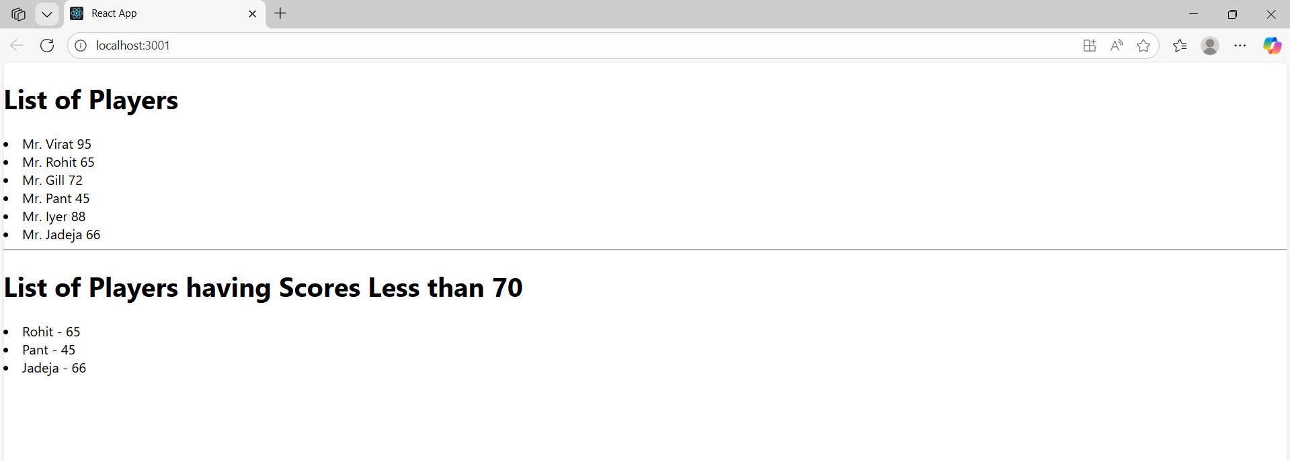

When Flag=false;

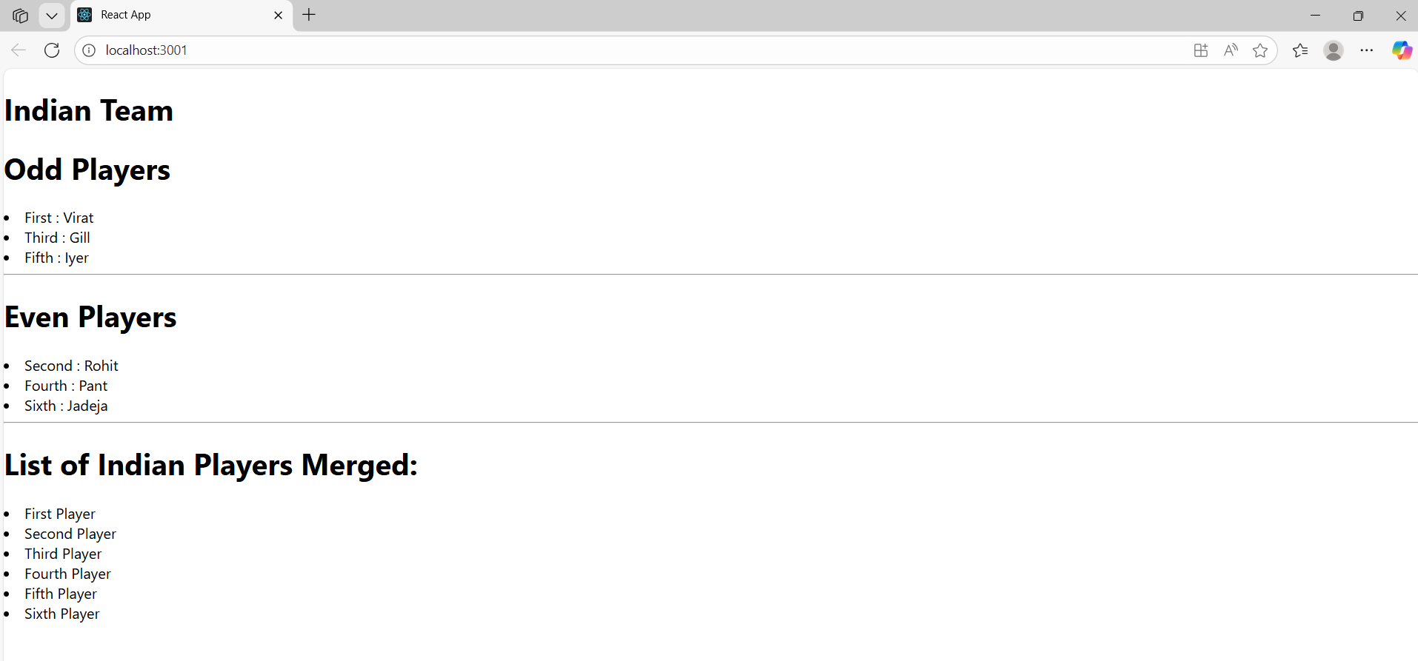

**10.Create a React Application named “officespacerentalapp” which uses React JSX to create elements, attributes and renders DOM to display the page.**

**Create an element to display the heading of the page.**

**Attribute to display the image of the office space**

**Create an object of office to display the details like Name, Rent and Address.**

**Create a list of Object and loop through the office space item to display more data.**

**To apply Css, Display the color of the Rent in Red if it’s below 60000 and in Green if it’s above 60000.**

App.js:

import React from "react";

import "./App.css";

import officeImg from "./office.jpg";

function App() {

const element = "Office Space";

const jsxatt = <img src={officeImg} width="25%" height="25%" alt="Office Space" />;

const ItemName = { Name: "DBS", Rent: 50000, Address: "Chennai" };

let colors = [];

if (ItemName.Rent <= 60000) {

colors.push("textRed");

} else {

colors.push("textGreen");

}

const officeList = [

{ Name: "DBS", Rent: 50000, Address: "Chennai" },

{ Name: "Regus", Rent: 65000, Address: "Bangalore" },

{ Name: "WeWork", Rent: 55000, Address: "Hyderabad" }

];

return (

<div>

<h1>{element}, at Affordable Range</h1>

{jsxatt}

<h1>Name: {ItemName.Name}</h1>

<h3 className={colors[0]}>Rent: Rs. {ItemName.Rent}</h3>

<h3>Address: {ItemName.Address}</h3>

<hr />

<h2>Office List:</h2>

<ul>

{officeList.map((office, index) => {

let rentColors = [];

if (office.Rent <= 60000) {

rentColors.push("textRed");

} else {

rentColors.push("textGreen");

}

return (

<li key={index}>

<b>{office.Name}</b> |

<span className={rentColors[0]}> Rent: Rs.{office.Rent}</span> |

Address: {office.Address}

</li>

);

})}

</ul>

</div>

);

}

export default App;

App.css:

.textRed {

  color: red;

}

.textGreen {

  color: green;

}

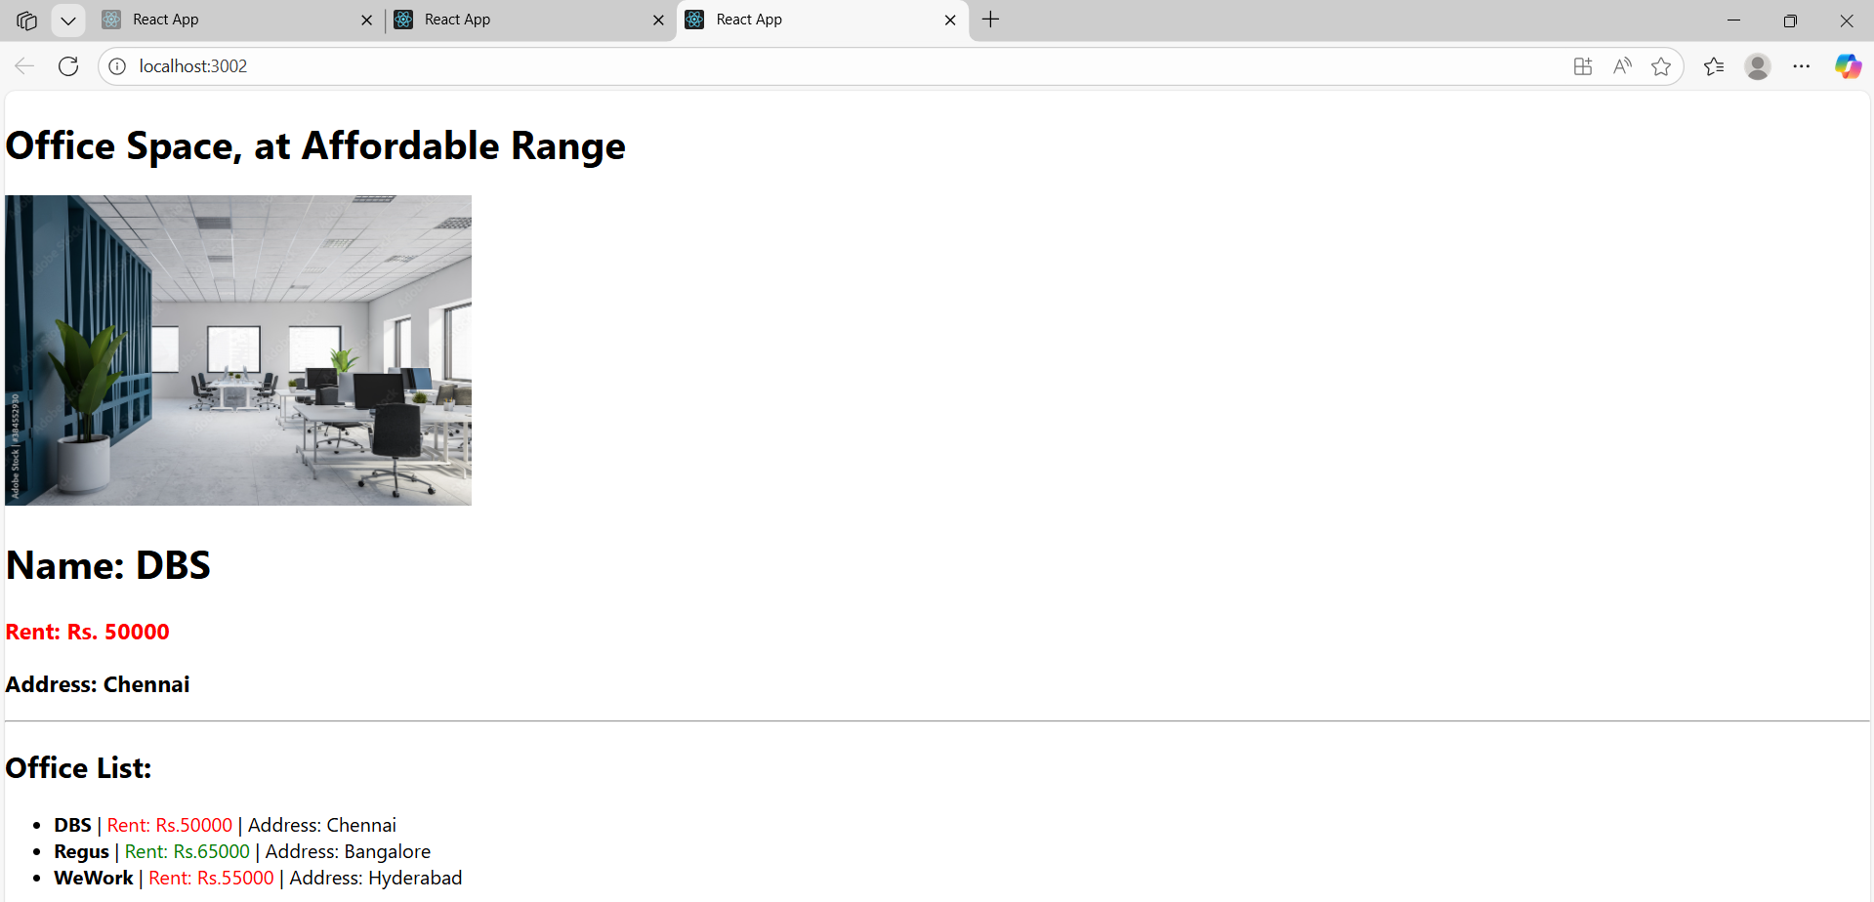

**11.Create a React Application “eventexamplesapp” to handle various events of the form elements in HTML.**

1. **Create “Increment” button to increase the value of the counter and “Decrement” button to decrease the value of the counter. The “Increase” button should invoke multiple methods.** 
   1. **To increment the value**
   2. **Say Hello followed by a static message.**

**Create a button “Say Welcome” which invokes the function which takes “welcome” as an argument.**

**Create a button which invokes synthetic event “OnPress” which display “I was clicked”**

**Create a “CurrencyConvertor” component which will convert the Indian Rupees to Euro when the Convert button is clicked.**

**Handle the Click event of the button to invoke the handleSubmit event and handle the conversion of the euro to rupees.**

CODE:

App.js:

import React, { useState } from "react";

import CurrencyConvertor from "./CurrencyConverter";

function App() {

  const [count, setCount] = useState(5);

  const increment = () => {

    setCount(count + 1);

    sayHello();

  };

  const decrement = () => {

    setCount(count - 1);

  };

  const sayHello = () => {

    alert("Hello! Member1");

  };

  const sayWelcome = (msg) => {

    alert(msg);

  };

  const handleClick = () => {

    alert("I was clicked");

  };

  return (

    <div>

      <h3>{count}</h3>

      <button onClick={increment}>Increment</button>

      <br /><br />

      <button onClick={decrement}>Decrement</button>

      <br /> <br />

      <button onClick={() => sayWelcome("Welcome")}>Say welcome</button>

      <br /> <br />

      <button onClick={handleClick}>Click on me</button>

      <hr />

      <CurrencyConvertor />

    </div>

  );

}

export default App;

CurrencyConverter.js:

import React, { useState } from "react";

function CurrencyConvertor() {

  const [amount, setAmount] = useState("");

  const [currency, setCurrency] = useState("");

  const handleSubmit = (e) => {

    e.preventDefault();

    if (currency.toLowerCase() === "euro") {

      const euroValue = (amount * 0.011).toFixed(2);

      alert(`${amount} INR = ${euroValue} EUR`);

    } else {

      alert("Currently only Euro conversion is supported. Type 'euro'.");

    }

  };

  return (

    <div>

      <h1 style={{ color: "green" }}>Currency Convertor!!!</h1>

      <form onSubmit={handleSubmit}>

        <p>

          Amount:{" "}

          <input

            type="number"

            value={amount}

            onChange={(e) => setAmount(e.target.value)}

          />

        </p>

        <p>

          Currency:{" "}

          <input

            type="text"

            value={currency}

            onChange={(e) => setCurrency(e.target.value)}

            placeholder="Type euro"

          />

        </p>

        <button type="submit">Submit</button>

      </form>

    </div>

  );

}

export default CurrencyConvertor;

When Clicked Increment:

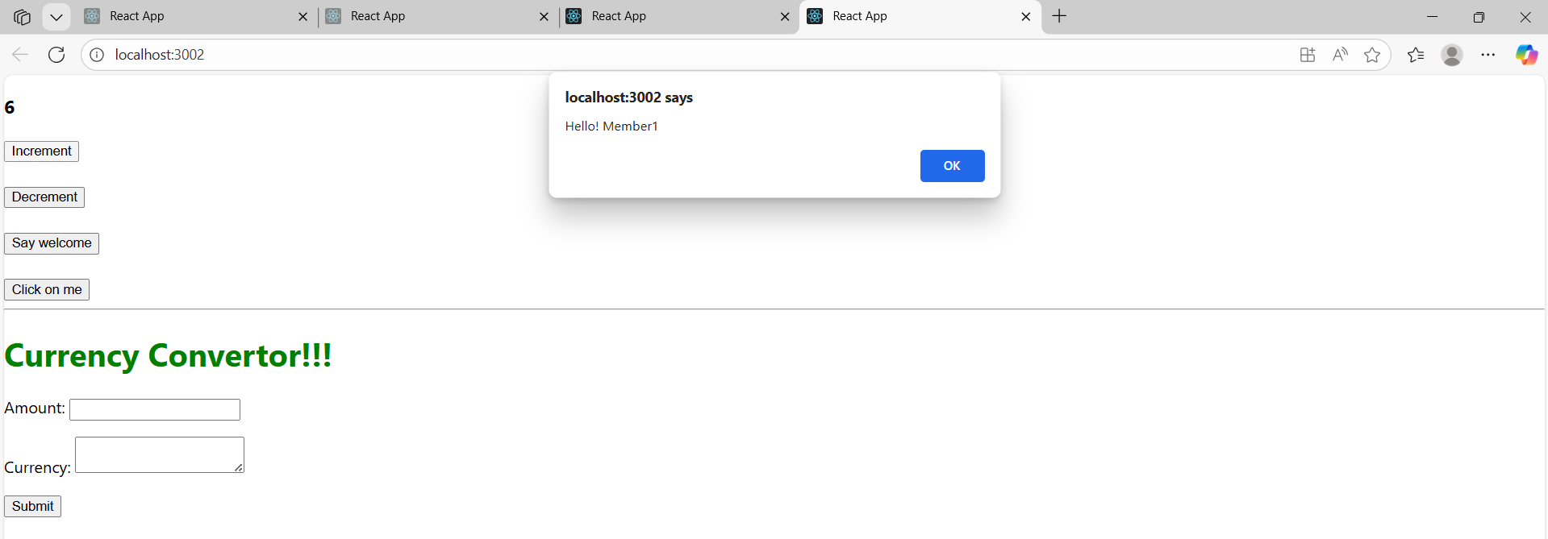

When Clicked Decrement:

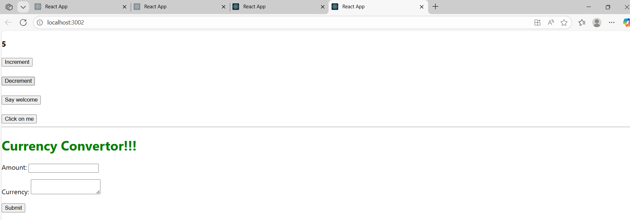

When clicked Say Welcome:

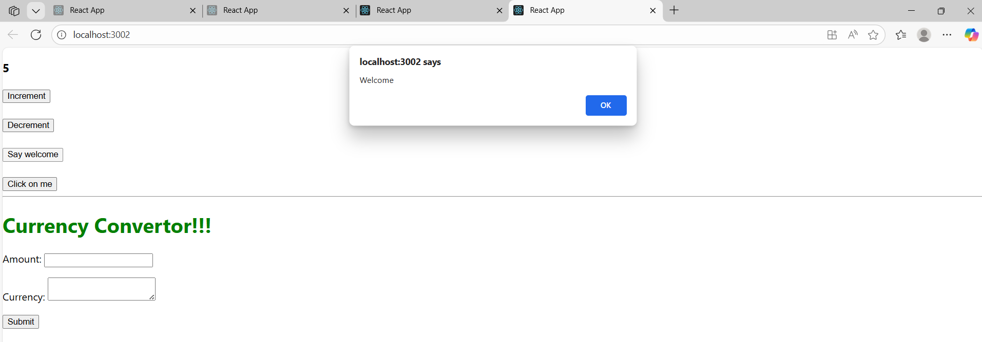

Currency Conversion:

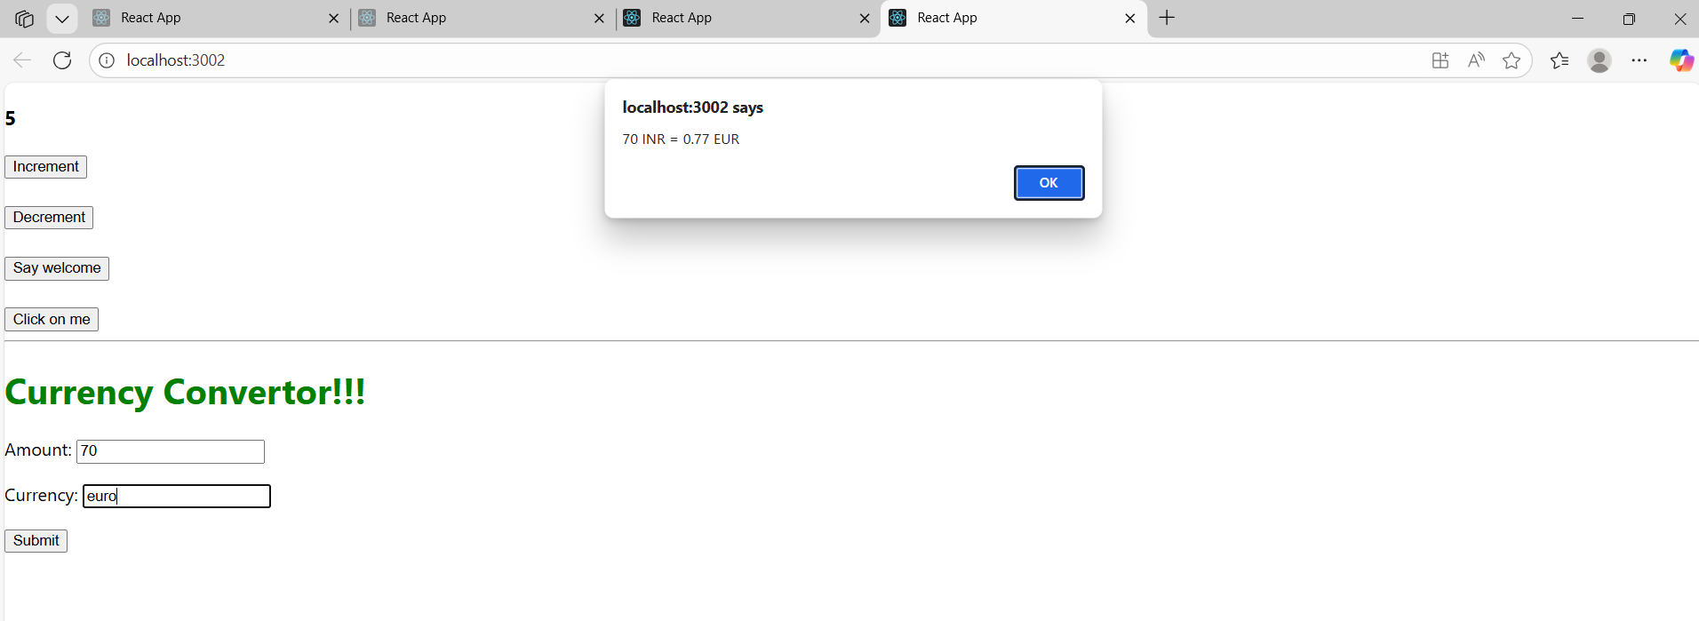

**12. Create a React Application named “ticketbookingapp” where the guest user can browse the page where the flight details are displayed whereas the logged in user only can book tickets.**

**The Login and Logout buttons should accordingly display different pages. Once the user is logged in the User page should be displayed. When the user clicks on Logout, the Guest page should be displayed.**

Greetings.js:

import React from "react";

function Greeting(props) {

  if (props.isLoggedIn) {

    return (

      <div>

        <h2>Welcome to Ticket Booking!</h2>

        <p>You can now book tickets.</p>

      </div>

    );

  } else {

    return (

      <div>

        <h2>Login Here!!!</h2>

        <p>Browse available flights. Login to book tickets.</p>

      </div>

    );

  }

}

export default Greeting;

import React from "react";

function LoginButton(props) {

  return (

    <button onClick={props.onClick}>

      Login

    </button>

  );

}

export default LoginButton;

import React from "react";

function LogoutButton(props) {

  return (

    <button onClick={props.onClick}>

      Logout

    </button>

  );

}

export default LogoutButton;

App.js:

import React, { useState } from "react";

import LoginButton from "./LoginButton";

import LogoutButton from "./LogoutButton";

import Greeting from "./Greeting";

function App() {

  const [isLoggedIn, setIsLoggedIn] = useState(false);

  const handleLogin = () => {

    setIsLoggedIn(true);

  };

  const handleLogout = () => {

    setIsLoggedIn(false);

  };

  return (

    <div>

      <h1>Ticket Booking App</h1>

      <Greeting isLoggedIn={isLoggedIn} />

      {isLoggedIn ? (

        <LogoutButton onClick={handleLogout} />

      ) : (

        <LoginButton onClick={handleLogin} />

      )}

    </div>

  );

}

export default App;

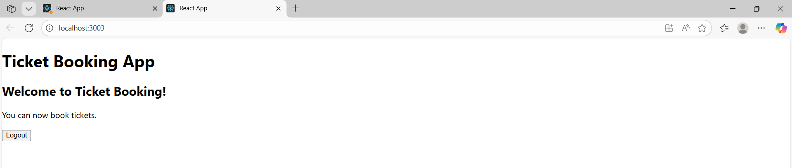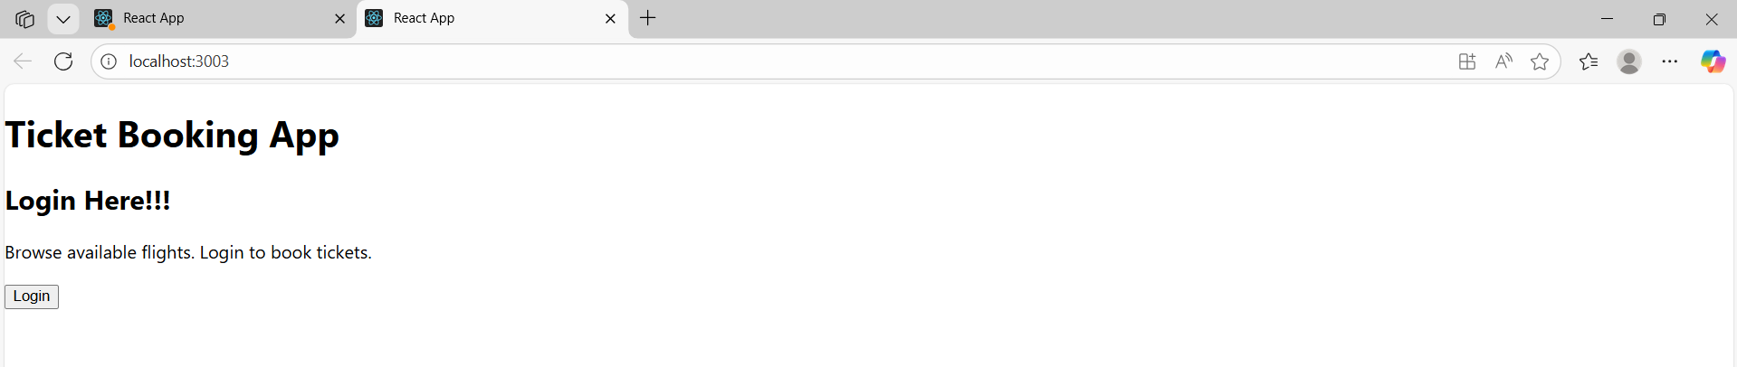

**13. Create a React App named “bloggerapp” in with 3 components.**

1. **Book Details**
2. **Blog Details**
3. **Course Details**

**Implement this with as many ways possible of Conditional Rendering.**

App.js:

import React from 'react';

import './App.css';

import BookDetails from './BookDetails';

import BlogDetails from './BlogDetails';

import CourseDetails from './CourseDetails';

import { books } from './books';

import { blogs } from './blogs';

import { courses } from './courses';

function App() {

  const bookdet = <BookDetails books={books} />;

  const content = <BlogDetails blogs={blogs} />;

  const coursedet = <CourseDetails courses={courses} />;

  return (

    <div className="container">

      <div className="section mystyle1">

        <h1>Course Details</h1>

        {coursedet}

      </div>

      <div className="section st2">

        <h1>Book Details</h1>

        {bookdet}

      </div>

      <div className="section v1">

        <h1>Blog Details</h1>

        {content}

      </div>

    </div>

  );

}

export default App;

BlogDetails.js:

import React from 'react';

const BlogDetails = (props) => {

  return (

    <ul>

      {props.blogs.map((blog) => (

        <div key={blog.id}>

          <h3>{blog.title}</h3>

          <h4>{blog.author}</h4>

          <p>{blog.content}</p>

        </div>

      ))}

    </ul>

  );

};

export default BlogDetails;

export const blogs = [

  { id: 201, title: 'React Learning', author: 'Stephen Biz', content: 'Welcome to learning React!' },

  { id: 202, title: 'Installation', author: 'Schewzdenier', content: 'You can install React from npm.' },

];

BookDetails.js:

import React from 'react';

const BookDetails = (props) => {

  return (

    <ul>

      {props.books.map((book) => (

        <div key={book.id}>

          <h3>{book.bname}</h3>

          <h4>{book.price}</h4>

        </div>

      ))}

    </ul>

  );

};

export default BookDetails;

export const books = [

  { id: 101, bname: 'Master React', price: 5000 },

  { id: 102, bname: 'Angular 11', price: 1000 },

  { id: 103, bname: 'Mongo Essentials', price: 4000 },

];

CourseDetails.js:

import React from 'react';

const CourseDetails = (props) => {

  return (

    <ul>

      {props.courses.map((course) => (

        <div key={course.id}>

          <h3>{course.name}</h3>

          <h4>{course.date}</h4>

        </div>

      ))}

    </ul>

  );

};

export default CourseDetails;

export const courses = [

  { id: 301, name: 'Angular', date: '4/5/2025' },

  { id: 302, name: 'React', date: '16/6/2025' },

  { id: 303, name: 'SpringBoot', date: '20/7/2025' },

];

